Algorithms and Data Structures
Exercise 1: E-commerce Platform Search Function
- Code:
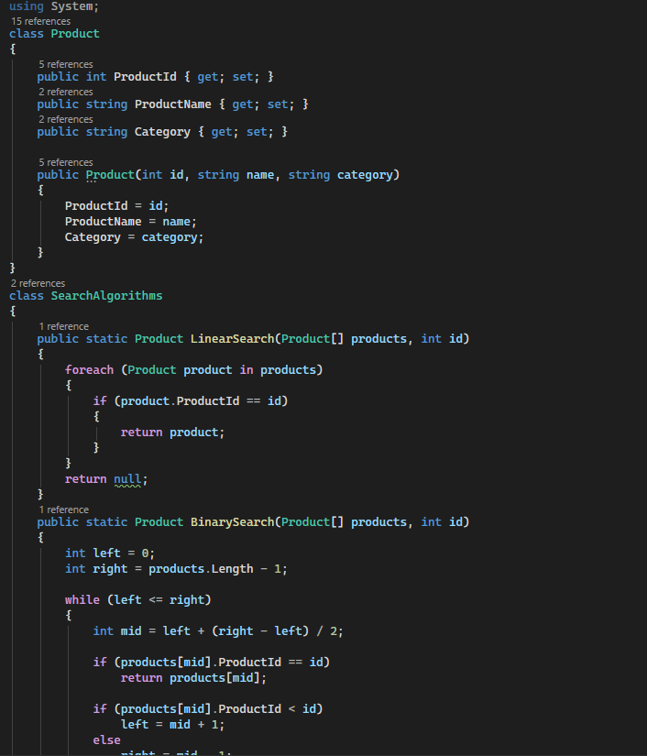
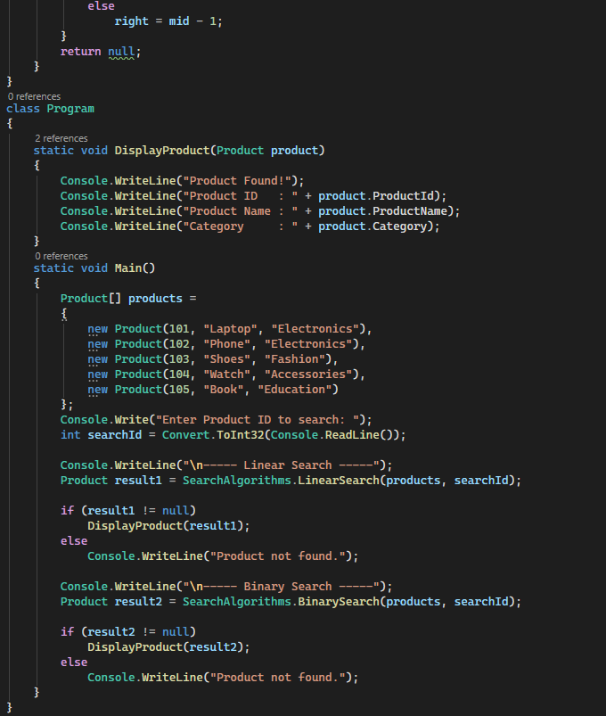

- Output:


- Analysis:
- Linear Search: O(n) – searches each element sequentially.
- Binary Search: O(log n) – searches efficiently on sorted data.
- Suitable Algorithm: Binary Search, because it is much faster for large, sorted product lists and improves search performance.

Exercise 7: Financial Forecasting

- Code:
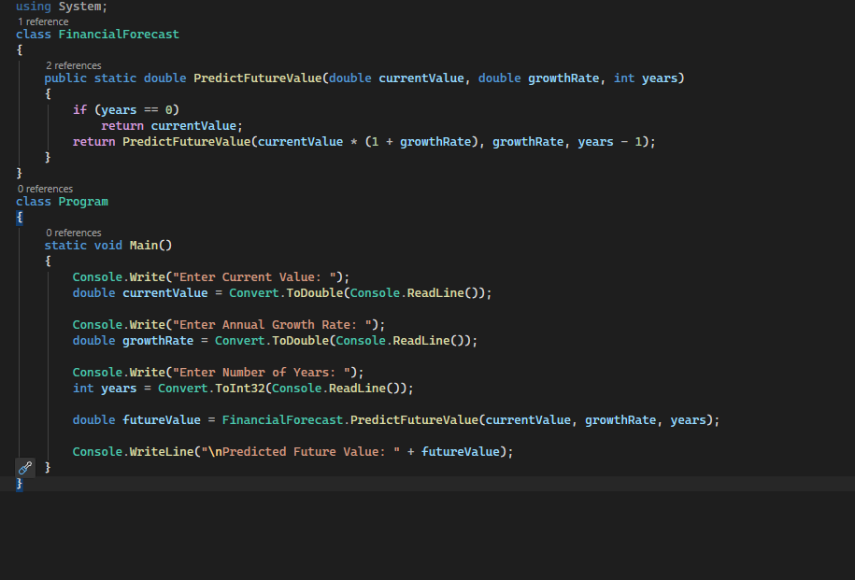
- Output:
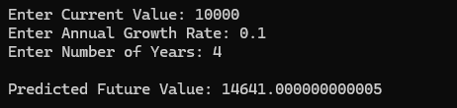

- Analysis:
- Time Complexity: O(n)
- Optimization: Use memoization or iteration for better efficiency

